Recompilation Document
……………………………….

We need to login to m/f by using below command
-> TSO USERID
->PASSWORD USERPASSWORD

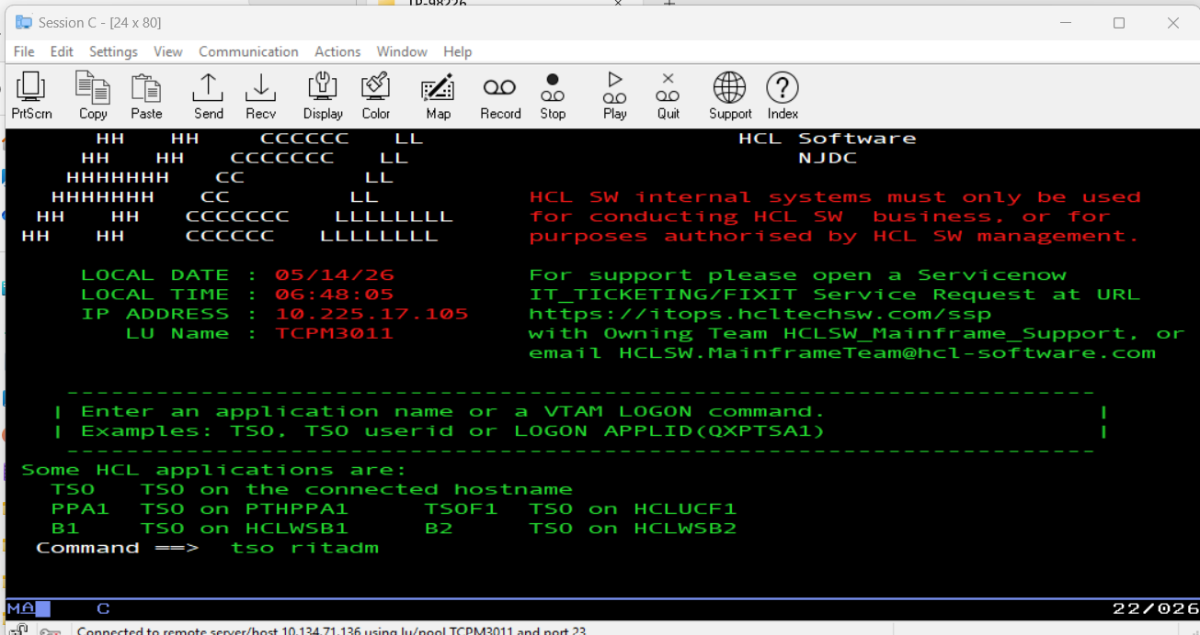

Then we need to access dataset ‘RITBLD.BUILD.JCL’

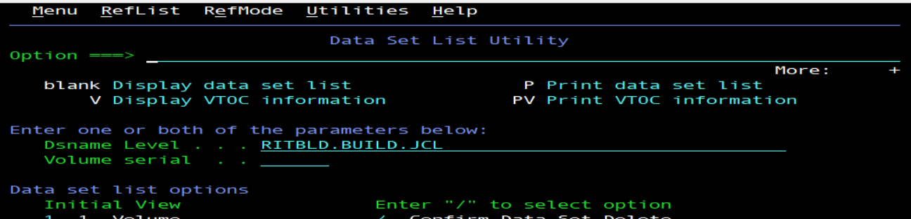

We need to search for these CIB090*(B for 11 ,0 for 0,8 for 8 i.e 11.0.8) or MQ JCL’s

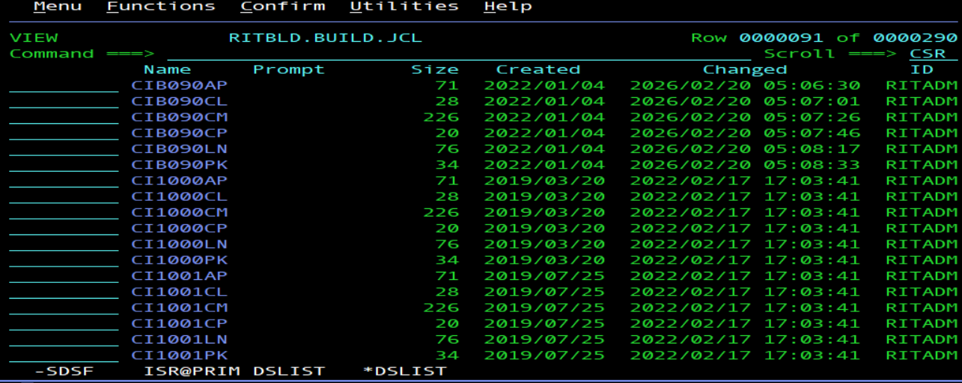

Then we need to copy the members to new names for below CICS members and MQ members:
CIB080AP
CIB080CL
CIB080CM
CIB080CP
CIB080LN
CIB080PK

To

CIB090AP
CIB090CL
CIB090CM
CIB090CP
CIB090LN
CIB090PK

We need to changes the new members data in jcl from 1108 to 1109’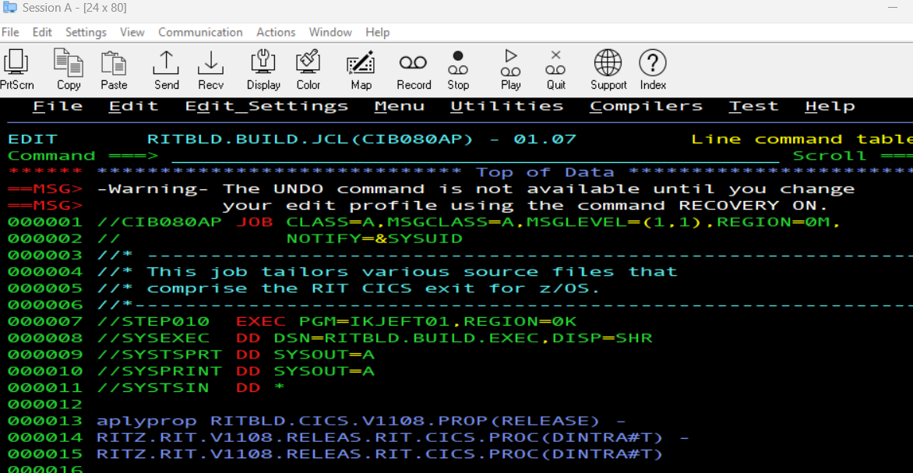

Then we need to copy the file RITBLD.CICS.V1108.PROP(RELEASE) to RITBLD.CICS.V1109.PROP(RELEASE)
And change the data in the file from 11.0.8 to 11.0.9 or 1108 to 1109 and change the date in BUILDLEVEL=20260220-1800 .Same is done for for the MQ datasets
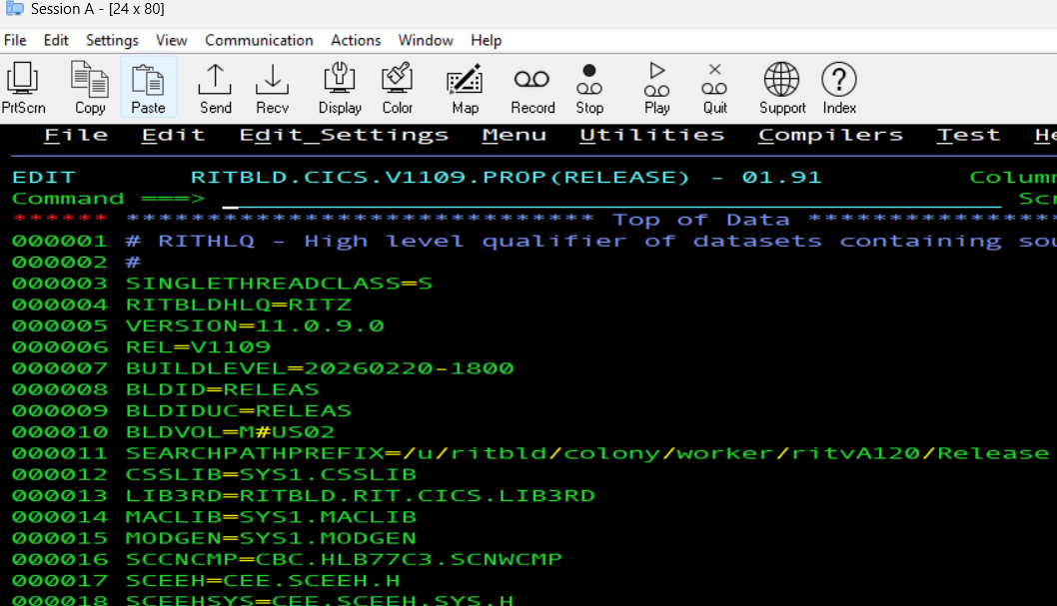

Then we will submit the jobs in the following sequence :

CIB090CL
CIB090CP
CIB090AP
CIB090CM
CIB090LN
CIB090PK

The pax code in the spool for CIB090CP should be 0 ,otherwise there might be some issue.
.
Before submitting the above job ,we need to copy the files also from VM to to omvs by following commands:
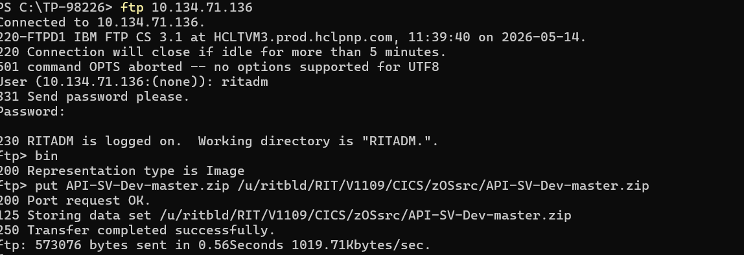

We need to create the folder at OMVS system(unix system) by using following commands,These are the commands common for both CICS and MQ.

TSO OMVS
Cd /u/ritbld/RIT/
MKDIR V1109
CP -r /u/ritbld/RIT/V1108/. /u/ritbld/RIT/V1109/

You can check the status of jobs in spool by using ‘s’ command for MQ and CICS for jobs starting with HRV* or CIB*
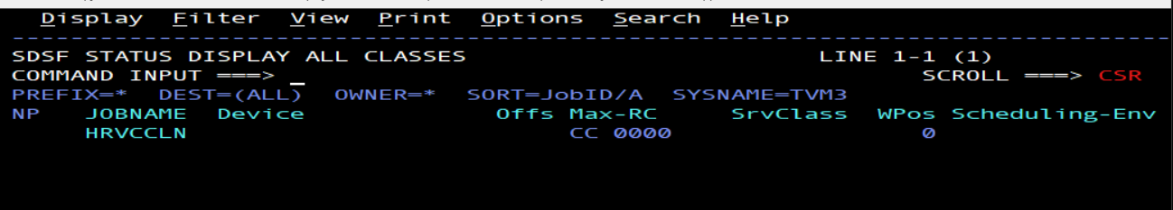

For further testing related to MQ ,you need to refer to below doc: https://help.hcl-software.com/devops/test/integration/10.2.1/docs/topics/t_testing_with_wmq.html

For further testing related for CICSagent ,you can refer to below doc:
https://help.hcl-software.com/devops/test/integration/10.2.1/docs/topics/t_test_cics.html

